Title of Paper
12-Point Bold Times Roman Font

Hany Farouk¹, PhD and Hesham K. Ameen², PhD

¹CEO, Soil-Structure Interaction Group in Egypt (SSIGE), Cairo, Egypt, hanyfarouk808@gmail.com.
²Head of the Geo-Institute of the HBRC, Dokki, Giza, Egypt.

ABSTRACT: The abstract should be roughly 300 words long. All text for the manuscript should be in 12-point Times Roman font with single spacing. Kindly use the International A4 type paper, and use 3.5 cm for the top & bottom margins and 3.25 cm for the left & right margins. Use bold UPPERCASE for the ABSTRACT, INTRO, and all major headings. Use bold lowercase with capitalization for next-level headings.

INTRODUCTION

Please write a brief introduction describing your manuscript. Use both the oldest and latest references in order to make your paper stronger.

Sub-heading Title
Please don’t add tables within the text of your paper; instead, place them at the end of your manuscript, after the references and before the figures. Please use the same font styles and include a legend title at the top. Numerate the tables in the same sequence as they are introduced in the text.

Leave one blank line between headings and text, as well as tables & figures. Equations should be numbered consecutively within parentheses (1) and positioned flush with the right margin.

Second Sub-heading Title
Insert figures, photos, and graphics directly after the Tables at the end of the manuscript and add a (bold TR) caption beneath the figure, but put the table title above the table.

Conclusions
Here you should directly and clearly present your findings.

Acknowledgments
Here you should only mention those people who actually helped in finalizing the work. Don’t use this for promotion.

References

Dipendra Gautam et.al. (2016). Common structural and construction deficiencies of Nepalese. Innovative Infrastructure Solutions journal, Springer. doi: 10.1007/s41062-016-0001-3
Farouk, H. (2016). Retaining walls with relief shelves. Innovative Infrastructure Solutions journal, Springer. doi: 10.1007/s41062-016-0007-x
Jayalekshmi B.R. and Chinmayi H.K. (2016). Effect of soil stiffness on seismic response of reinforced concrete buildings with shear walls. Innovative Infrastructure Solutions journal, Springer. doi: 10.1007/s41062-016-0004-0
Neelima Satyam and Pallavi Badry (2016). An Efficient approach for assessing the seismic soil structure interaction effect for the asymmetrical pile group. Innovative Infrastructure Solutions journal, Springer. doi: 10.1007/s41062-016-0003-1

TABLES

Table 1. Example

Title of Entry | S₁ | S₂ | Total Settlement
Footing 1 | 0.10 | 2.76 | 2.86
Footing 2 | 0.14 | 3.72 | 3.86

FIGURES
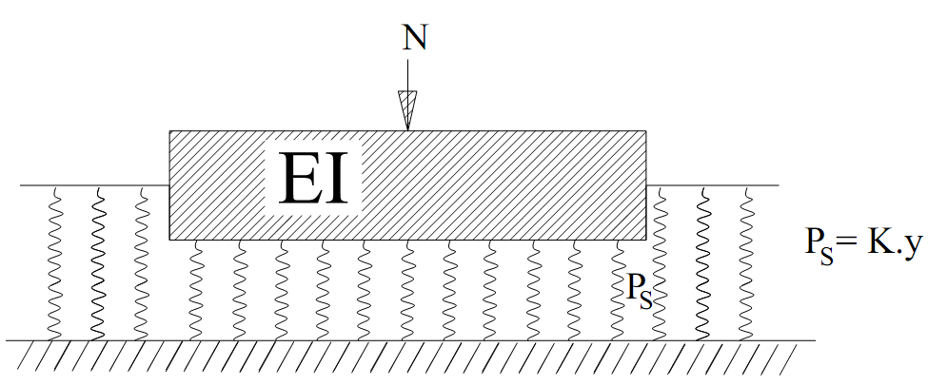

FIG. 1. The soil as an infinite number of springs

